Notes on ANGLE MEASUREMENT.
I really, really, really like the following approach……………do try it !
1. An ANGLE is an amount of rotation. Ask them. Probably nobody will remember this!

2. The “basic” angle is 1 FULL TURN ……..

3. So a HALF TURN is ……..

4. The most famous and useful angle is
a QUARTER TURN or RIGHT ANGLE….. or
(we could have an eighth turn, a tenth turn etc.)
5. Notice there has been no mention of “degrees” to explain ANGLE.

THE FOLLOWING “STORY” IS MOST WORTHWHILE. DO TRY IT.
6. The Ancient Babylonians did a lot of mathematics and astronomy and by studying the stars they found that every night, they were in slightly different positions.
To their surprise, they found that after 360 days, the stars were back in the same positions. (Actually, it was really 365 days, a whole year, because the earth had moved right round the sun back to the original position) With their limited apparatus, it was remarkable they even got 360 as their answer!
The number 360 became a special number with powerful properties so they simply CHOSE this number, 360, as the number of divisions a full turn should be divided into.
And we still use 360 degrees = 1 full turn, for no other good reason !!!

7. At the time of the French revolution, they decided to make everything metric so they chose the most common angle, a RIGHT ANGLE, and let it be 100 divisions.
They called these GRADS. A right angle = 100 grads, a half turn = 200 grads and a full turn = 400 grads. (Metres, Kg and Litres became popular but not Grads)

8. Actually, all modern scientific calculators have degrees and grads on them!
9. A Degree protractor A Grad protractor
90 100

180 0 200 0

270 300

THIS PROTRACTOR USES GRADS NOT DEGREES!!!

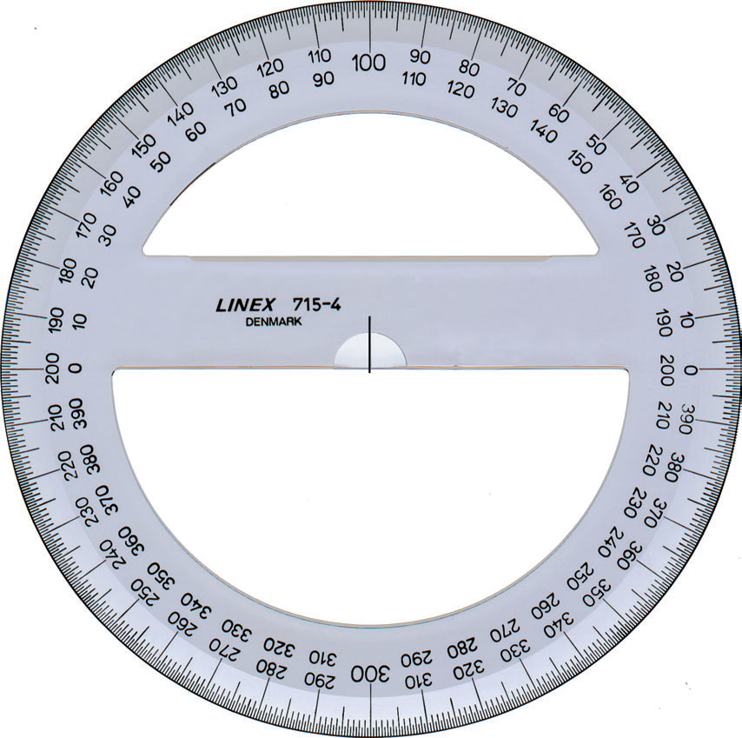

10. RADIANS. The ONLY real reason for using radians is when we
Differentiate/Integrate trig functions! lim sin h = 1
^{h0} h
Definition: 1 radian is the angle formed by a circular arc of 1 unit in a
circle of radius 1 unit.

1 1 1 1
1 rad 60⁰

- 1

If you imagine the arc straightened out you would get an Equilateral triangle so the angle would be 60⁰. This means a radian is a little less than 60⁰.

1 2 Clearly, this angle is 2 rads

1

1 3.7 Clearly, this angle is 3.7 rads

1

The way to get a way to change radians to degrees is to consider a full turn.
Clearly the angle in degrees is 360⁰

In radians, all we need to do is find the length of the arc which in this case is the full circumference of a circle = 2πr
= 2π×1
= 2π

So 360 degrees = 2π rads ≈ 6.2 rads

1

Students need to be confident changing from rads to degrees and vice versa.

RADS | DEGREES
2π | 360
π | 180  This is the one to work with!
π  2 | 180 = 90  2
π  3 | 180 = 60  3
π  4 | 180 = 45  4
π  6 | 180 = 30  6
3π  2 | 3 × 90 = 270
2π  3 | 2 × 60 = 120
5π  3 | 5 × 60 = 300
3π  4 | 3 × 45 = 135
7π  6 | 7 × 30 = 210

The special “aesthetic quality” of radians is simply a myth!

Both “radians” and “degrees” are really just different ways of measuring angles, just as “metres” and “feet” are just different ways of measuring lengths.

The requirement for students to use only radians at this level is making mathematics more inaccessible than it needs to be.
____________________________________________________________

In this example θ = π = 30⁰
6
We do not need special radian formulae to find arc length and areas of sectors.
L This is simply 30^{ths} or 1th of a full circle.
360 12

θ so arc length L = 1 × π d = 1 × π × 12 = π cm
r = 6cm 12 12

and Area A = 1 × π r² = 1 × π × 36 = 3π cm²
12 12

There is never a need to resort to formulae such as L = rθ or A = ½ r²θ when all that is required is simple LOGIC. (ie what fraction of a circle is it!)

My next point is this: Who REALLY uses radians?

Ask any mathematician or scientist to visualise an angle of 4.7 rads.
On the other hand, ask any Year 9 student to visualise an angle of 269⁰ and
they will confidently come up with an angle as follows :

Now be honest, did YOU know that 4.7 rads

is just a little less than 270⁰ ?

When we SAY we are “using radians”, we are usually talking about angles such as:
π , π , 3π , 2π etc
6 4 2

Again, if we are honest, when we are talking about π radians
6
we really mean 30⁰.

Actually, π radians is really just 30⁰ in disguise !!
6
We could even say π radians is just like a “secret code” for 30 degrees!
6

The actual value of π is of course 0.523598775…
6
How silly is that? Not a very useful number to deal with!

Similarly π rad is really 45⁰ , 3π rad is really 270⁰
4 2

We do not often use angles of π for instance,
7
simply because it has no nice equivalent in degrees!

Make these ideas clear.

π rad | 180⁰
so 1 rad | 180 =57.29577951… ≈ 60⁰  π
180⁰ | π rad
So 1 degree | π = 0.0174532..rad  180

The graph of y = sin x , where x is in degrees, is fine just the way it is.
The scales on x and y axes do not have to be the “same order of magnitude”.

y

1

90 180 270 360 450 540 x⁰

-1

Now here is a VERY interesting point.
When we draw a sine graph with a “radian scale”, this is what we draw:

1

π π 3π 2π 5π 3π
2 2 2
-1
This is an absolute fraud!
We are really marking the special x intercept points as they occur in degrees.

We would never think of drawing a sine graph with REAL RADIAN UNITS as follows:
? 3.14? ? 6.28?

1

-1
1 2 3 4 5 6 7 8 x

The intercepts on the x axis and positions of max/min points are not at all
obvious!

