FINDING THE EQUATION OF A TANGENT TO A CURVE FROM A POINT NOT ON THE CURVE.

1. Find the equation of the tangent to y = x² from the point (2, 3)

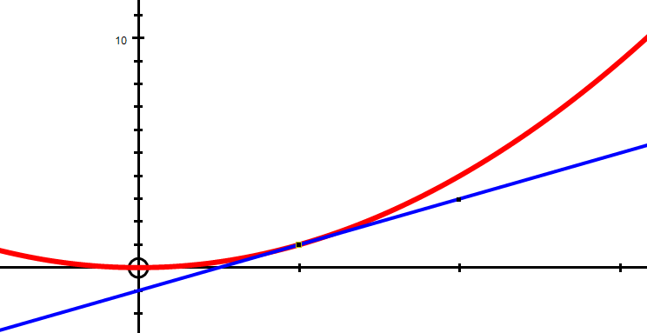
P
(2, 3)
In questions like this we do not know the coordinates of the point P where the tangent touches the curve.
If we let the x coordinate of P be a then the y coordinate will be a² (ie y = x²)
Using the gradient triangle drawn above we can say that the gradient of the tangent using points (2, 3) and (a, a²) will be 3 – a²
2 – a
We can find another value for the gradient at P by differentiating y = x²
Gradient y' = 2x and if x = a at P then the gradient of the tangent is 2a
Equating these two values we get : 2a = 3 – a²
2 – a
So that 2a(2 – a) = 3 – a²
4a – 2a² = 3 – a²
0 = a² – 4a + 3
0 = (a – 1)(a – 3)
a = 1 OR a = 3
This means there are TWO possible tangents from (2, 3) to the curve.

If a = 1 then P would be (1, 1), the gradient would be m = 2 and using y = mx + c substituting m = 2, x = 1, y = 1 we get c = –1
The tangent drawn in the above diagram is y = 2x – 1

If a = 3 then P would be (3, 9), the gradient would be m = 6 and using y = mx + c substituting m = 6, x = 3, y = 9 we get c = – 9
The other tangent drawn in the diagram below is y = 6x – 9

(3, 9)

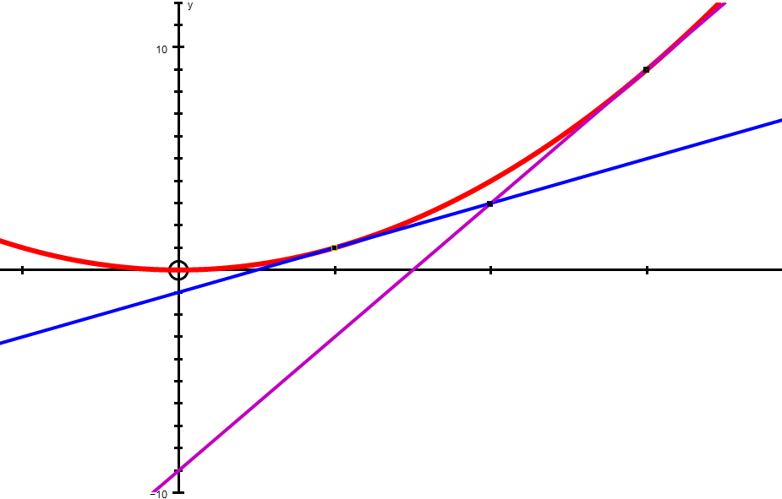
(1, 1)

y = 2x – 1

y = 6x – 9
(2, 3)
Q
P

This shows the TWO tangents from (2, 3) to the parabola y = x²
___________________________________________________________

2. Find the equation of the tangents to y = 3x – x² from the point (1, 3)

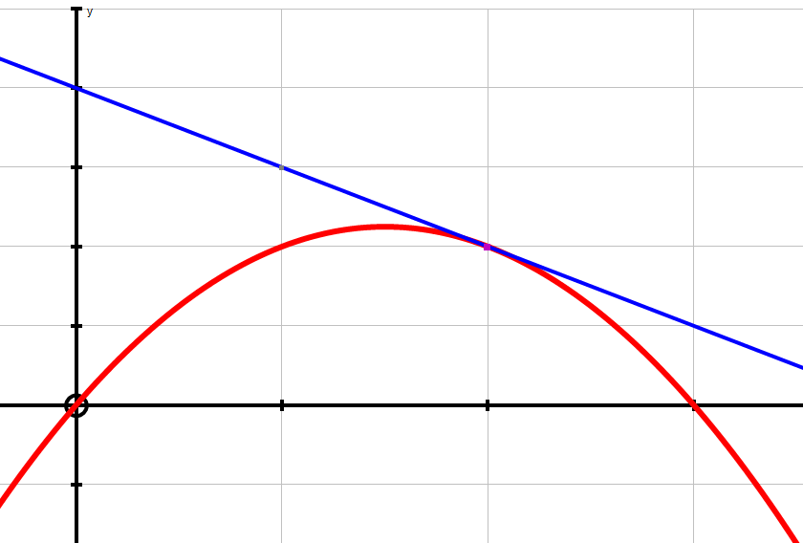
P (a, 3a – a²)
(1, 3)

Let P be the point where the tangent from (1, 3) touches the curve so the coordinates of P, are (a, 3a – a²).
Using the gradient triangle shown, the gradient of the tangent in terms of a is:
– (3 – 3a + a²)
(a – 1 )
Differentiating y' = 3 – 2x = 3 – 2a so equating these forms:
3 – 2a = – (3 – 3a + a²)
(a – 1 )
3a – 3 – 2a² + 2a = 3a – 3 – a²
0 = a² – 2a
So a = 0 or 2
If a = 2 then P is (2, 2) and the tangent equation is y = – x + 4
If a = 0 then P is (0, 0) and the other tangent equation is y = 3x (see dotted line )
3. Find the equation of the tangents to y = x³ from the point (2, 4)
It will become apparent that there are actually THREE tangents!
Consider the tangent drawn below:
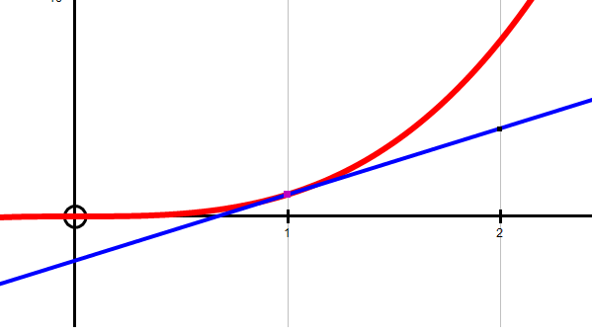
P(a, a³)
(2, 4)
Let the coordinates of the point where the tangent meets the curve be (a, a³)
Using the gradient triangle, the gradient of the tangent is 4 – a³
2 – a
Differentiating, we get y' = 3x² = 3a²
Equating these two expressions:
3a² = 4 – a³
2 – a
6a² – 3a³ = 4 – a³
0 = 2a³ – 6a² + 4
0 = a³ – 3a² + 2
0 = (a – 1)(a² – 2a – 2)
So that a = 1 or 1±√3
If a = 1, P is (1, 1) the gradient is 3 and the tangent is y = 3x – 2
If a = 1+√3, P is (1+√3, 20.39) the grad is 22.4 and the tan is y ≈ 22.4x – 40.8
If a = 1–√3, P is (1–√3, –0.39) the grad is 1.6 and the tan is y ≈ 1.6x –0.78
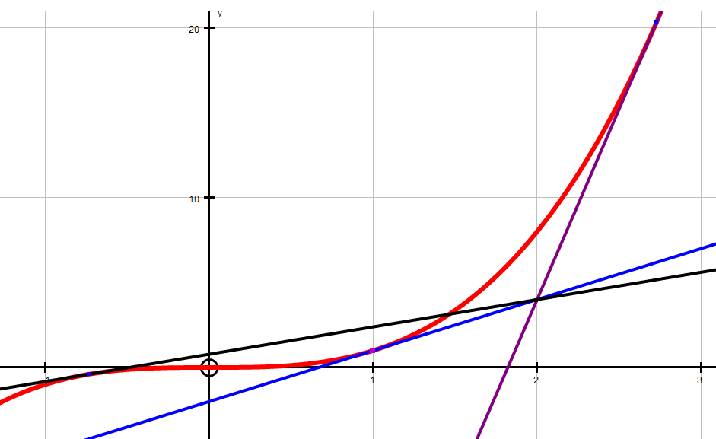
4. Find the equation of the tangent to y = x ^{½}– 2 from the point (–4, –2)
The graph is like this diagram…
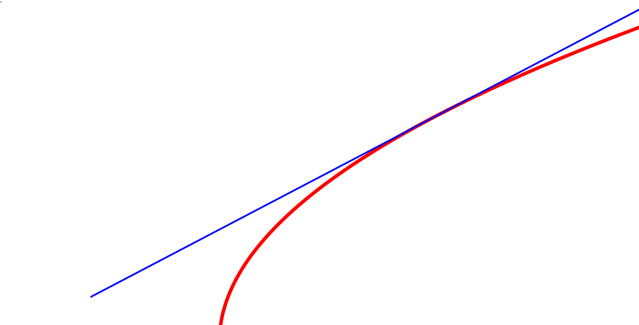
P (a, a ^{½} – 2 )
(–4, –2)

Let the tangent meet the curve at x = a so y = a ^{½} – 2

From the gradient triangle, the gradient of the tangent = a ^{½} – 2 + 2 = a ^{½}
a + 4 a + 4

If y = x ^{½}– 2 then y' = 1 so at x = a, the gradient of the tan is = 1
2 x^{½} 2 a^{½}

Equating these two expressions we get: a ^{½} = 1
a + 4 2a^{½}
hence 2a = a + 4
so that a = 4

The coordinates of P are (4, 0)
The gradient of the tangent = 1
4
The equation of the tangent is of the form y = mx + c
So substituting x = 4, y = 0, m = ¼ we get 0 = 1 + c so c = –1
The equation of the tangent is y = ¼x – 1
(4, 0)
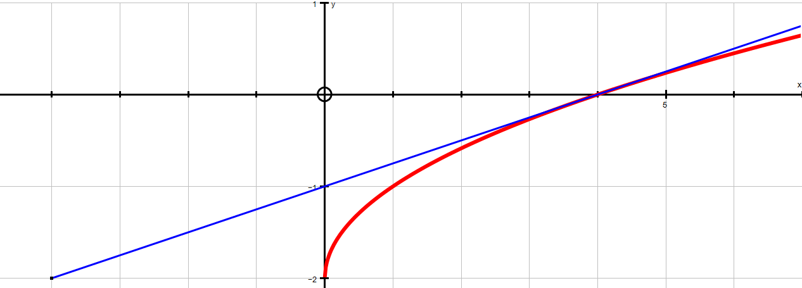
(–4, –2)

4. Find the equation of the tangents to y = x⁴ – 6x² from the point (0, 3)

Let the tangent meet the curve at x = a so y = a⁴ – 6a²

From the gradient triangle, the gradient of the tangent = a⁴ – 6a² – 3
a
If y = y = x⁴ – 6x² then y' = 4x³ – 12x
so at x = a, the gradient of the tangent is = 4a³ – 12a

Equating these two expressions we get: a⁴ – 6a² – 3 = 4a³ – 12a
a
so a⁴ – 6a² – 3 = 4a⁴ – 12a²

hence 0 = 3a⁴ – 6a² + 3
0 = 3(a² – 1)(a² – 1)
So a = 1 or – 1

If a = 1:
The coordinates of P are (1, –5)
The gradient of the tangent = –8
The equation of the tangent is of the form y = mx + c
So substituting x = 1, y = –5, m = –8 we get –5 = –8 + c so c = 3
The equation of the tangent is y = –8x + 3
If a = –1:
The coordinates of P are (–1, –5)
The gradient of the tangent = +8
The equation of the tangent is of the form y = mx + c
So substituting x = –1, y = –5, m = +8 we get –5 = –8 + c so c = 3
The equation of the tangent is y = +8x + 3

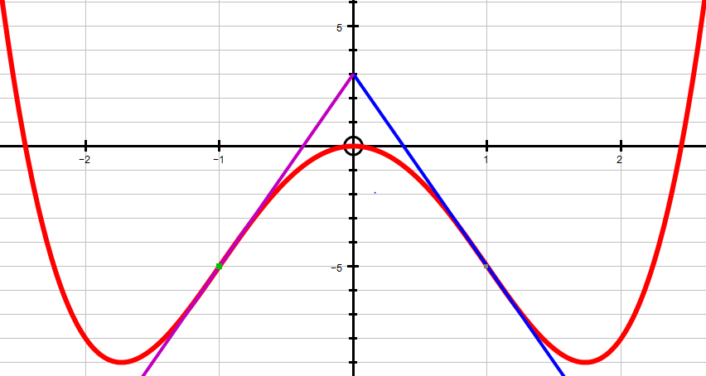
(–1, –5)
(1, –5)
(0, 3)

