Question from the QUORA website:
WHAT IS THE ORDER OF TRANSFORMATIONS IN GRAPHS?
I am not absolutely sure that the question is clear enough for me to give a general answer but I think that the following case may be instructive for your requirements.
Consider the graph of y = 1 + 3sin2(x – 180⁰)
This is a basic Sine Graph after several transformations.
There is a translation upwards, a stretch vertically (up and down), a translation sideways and a compression in the x direction but not in this order!

1. To illustrate each transformation I will just consider 2 periods of y = sin(x)
In this case – 360⁰ ≤ x ≤ 360⁰
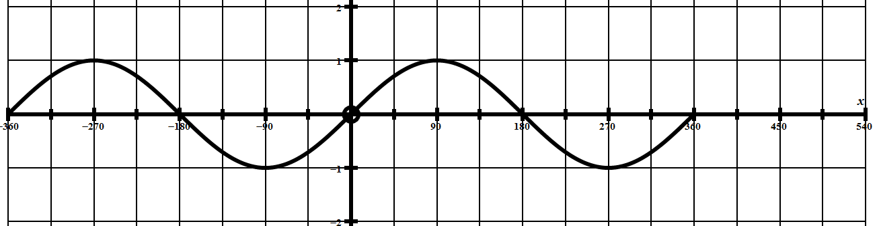

2. Now we need to consider the 1st transformation given by y = sin(x – 180)
which translates the graph 180 units in the positive x direction.
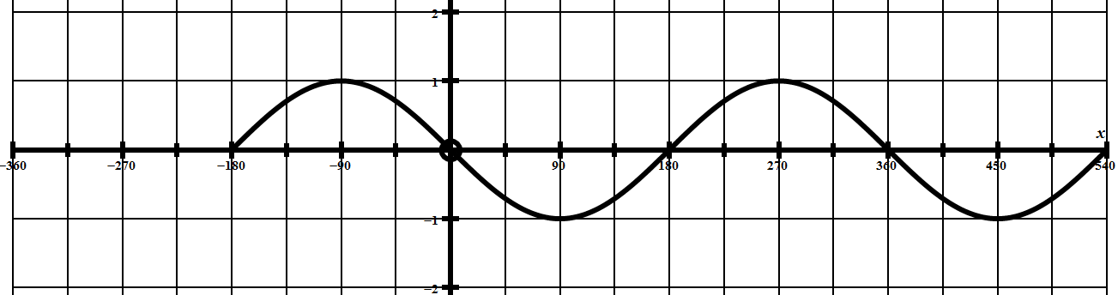

3. Now we consider the 2nd transformation given by y = sin2(x – 180)
This transformation compresses the graph in the x direction.
(Points ON the y axis remain in the same places)
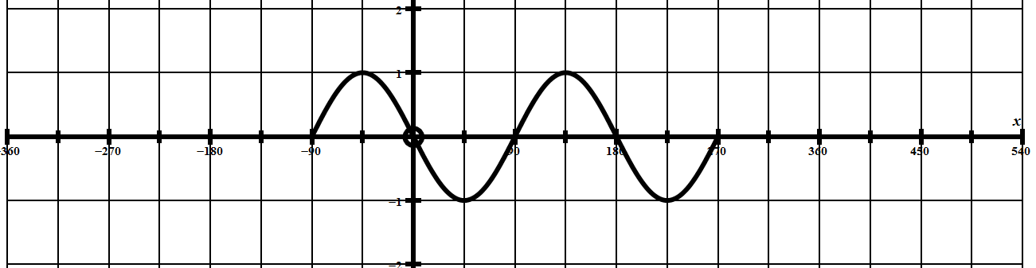

4. Now we consider y = 3sin2(x – 180) which stretches the
graph vertically up and down with a scale factor of 3.
(Points ON the x axis remain in the same places)

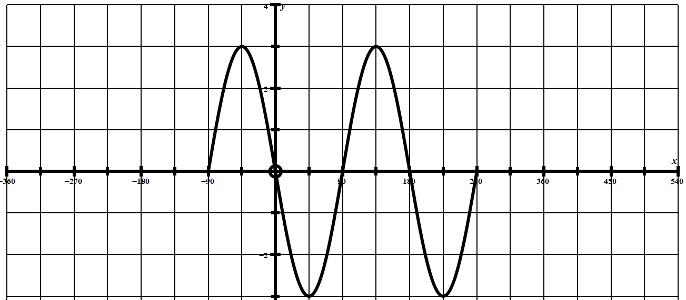

5. Finally, we consider y = 1 + 3sin2(x – 180) which simply translates the
graph 1 unit upwards.
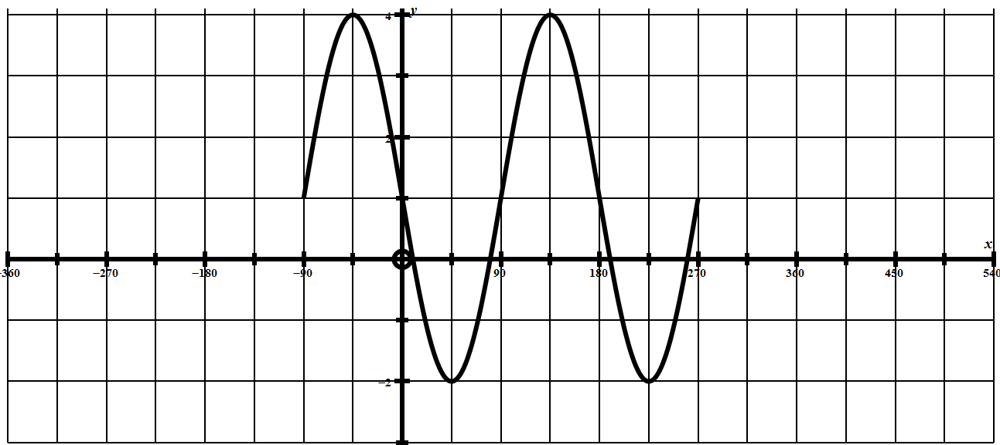

Normally we would not just consider two periods of a trigonometric function, I only did this to show how each transformation affects a fixed shape.
A full version of y = 1 + 3sin(2x – 180) is shown below:
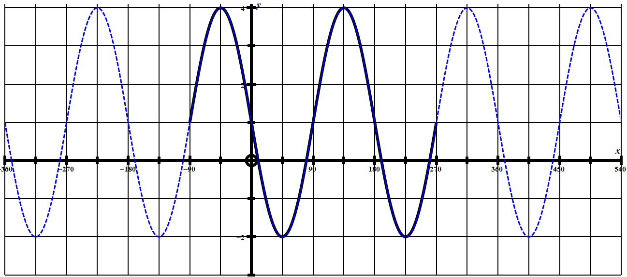

So to answer the question generally, we start from the “inside” and work to the “outside”.
Start with the basic case y = sin(x)
Then y = sin(x – 180) which translates the graph 180 units to the right.
Then y = sin2(x – 180) which compresses the graph in the x direction.
Then y = 3sin2(x – 180) which stretches the graph vertically.
Then y = 1 + 3sin2(x – 180) which translates the graph up 1 unit.

There is no actual “rule” for the order in which we do transformations, such as the rule for Order Of Arithmetical Operations commonly known as BIDMAS or something similar.
The topic is quite extensive and hard to cover with just one example.

