SINE GRAPHS.
1. The graph shown is y = sin(x)
On the axes below, draw the graphs:
(a) y = 2sin(x)
(b) y = 2sin(x) + 4

2. The graph shown is y = sin(x)
On the axes below, draw the graphs:
(a) y = 3sin(x)
(b) y = 3sin(x) + 5

3. What would the maximum and minimum y values be for the graph of
y = 8sin(x) + 7
MAX = MIN =
4. Find an equation in the form y = A + Bsin(x) so that the maximum value is 12
and the minimum value is 2

SINE GRAPHS.ANSWERS
1. The graph shown is y = sin(x)
On the axes below, draw the graphs:
(a) y = 2sin(x)
(b) y = 2sin(x) + 4

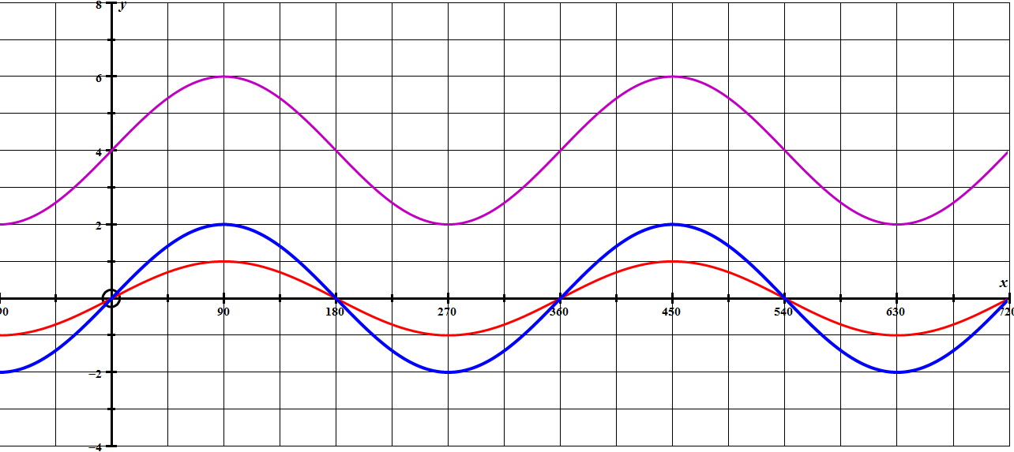

2. The graph shown is y = sin(x)
On the axes below, draw the graphs:
(a) y = 3sin(x)
(b) y = 3sin(x) + 5

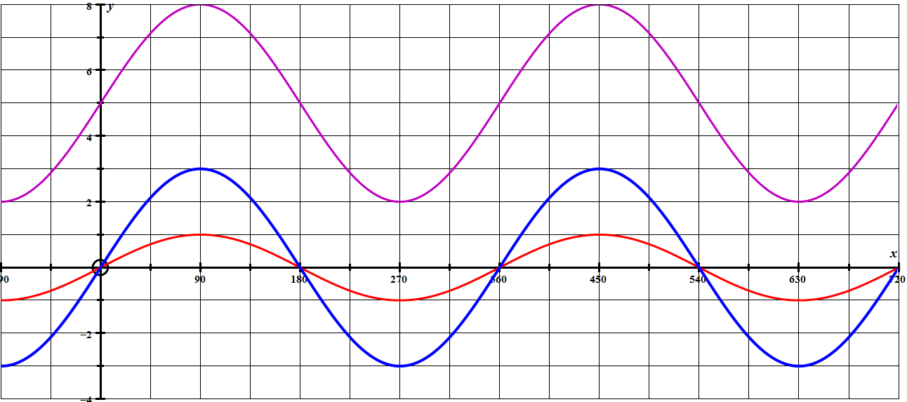

3. What would the maximum and minimum y values be for the graph of
y = 8sin(x) + 7
MAX = 15 MIN = 1
4. Find an equation in the form y = A + Bsin(x) so that the maximum value is 12
and the minimum value is 2 y = 7 + 5sin(x)
COSINE GRAPHS.
1. The graph shown is y = cos(x)
On the axes below, draw the graphs:
(a) y = 2cos(x)
(b) y = 2cos(x) + 5

2. The graph shown is y = cos(x)
On the axes below, draw the graphs:
(a) y = 3cos(x)
(b) y = 3cos(x) + 4

3. What would the maximum and minimum y values be for the graph of
y = 9cos(x) + 3
MAX = MIN =

4. Find an equation in the form y = A + Bcos(x) so that the
maximum value is 14 and the minimum value is 6.
COSINE GRAPHS.ANSWERS
1. The graph shown is y = cos(x)
On the axes below, draw the graphs:
(a) y = 2cos(x)
(b) y = 2cos(x) + 5

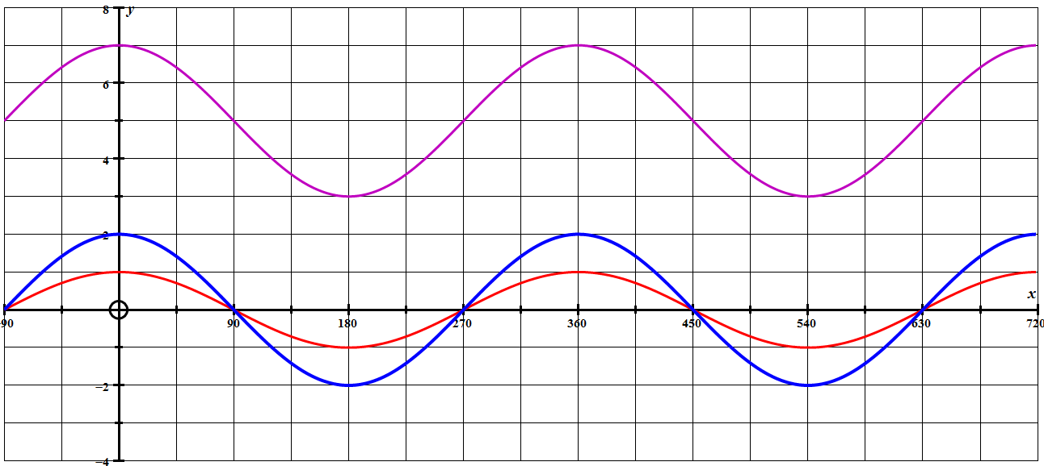

2. The graph shown is y = cos(x)
On the axes below, draw the graphs:
(a) y = 3cos(x)
(b) y = 3cos(x) + 4
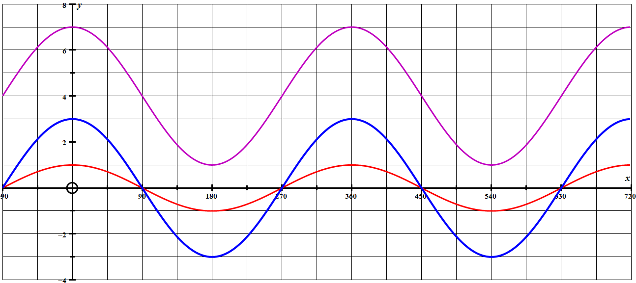

3. What would the maximum and minimum y values be for the graph of
y = 9cos(x) + 3
MAX = 12 MIN = 6

4. Find an equation in the form y = A + Bcos(x) so that the
maximum value is 14 and the minimum value is 6.
y = 4cos(x) + 10
Changing the PERIOD of trigonometric graphs.
1. The graph below is y = sin(x) for 0 ≤ x ≤ 360⁰
Draw the graph of y = sin(2x) for 0 ≤ x ≤ 360⁰

2. The graph below is y = sin(x) for 0 ≤ x ≤ 360⁰
Draw the graph of y = sin(4x) for 0 ≤ x ≤ 360⁰
3. The graph below is y = cos(x) for -90 ≤ x ≤ 360⁰
Draw the graph of y = cos(2x) for -90 ≤ x ≤ 360⁰

4. Draw the graph of just 1 period of y = sin(20x) on the axes below.

5. Draw the graph of just 1 period of y = sin(30x) on the axes below.

6. Draw the graph of just 1 period of y = cos(30x) on the axes below.

Changing the PERIOD of trigonometric graphs.ANSWERS.
1. The graph below is y = sin(x) for 0 ≤ x ≤ 360⁰
Draw the graph of y = sin(2x) for 0 ≤ x ≤ 360⁰
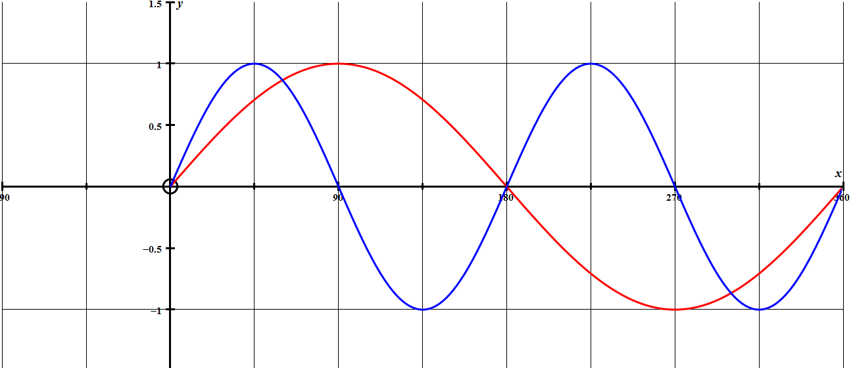

2. The graph below is y = sin(x) for 0 ≤ x ≤ 360⁰
Draw the graph of y = sin(4x) for 0 ≤ x ≤ 360⁰
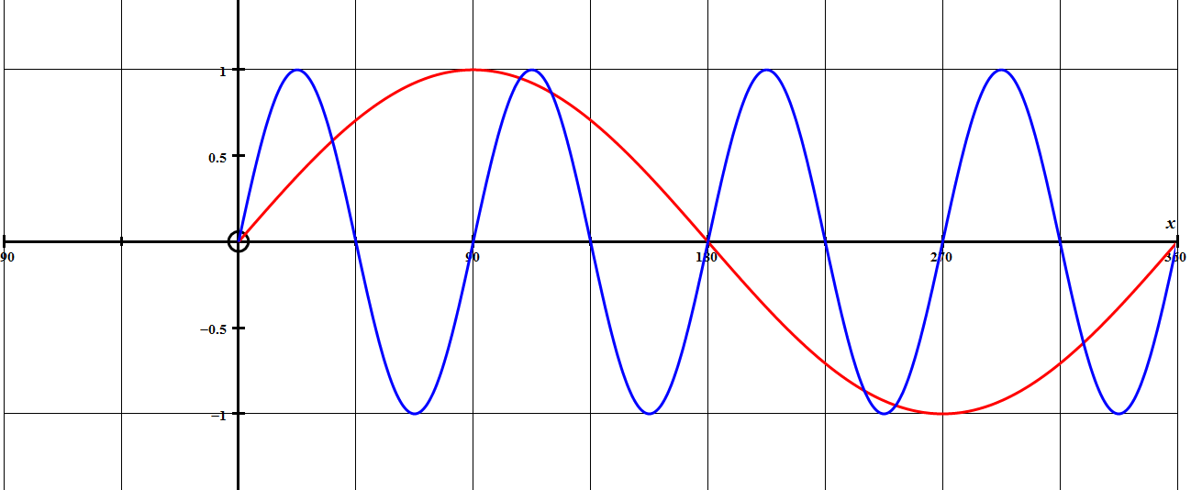
3. The graph below is y = cos(x) for -90 ≤ x ≤ 360⁰
Draw the graph of y = cos(2x) for -90 ≤ x ≤ 360⁰
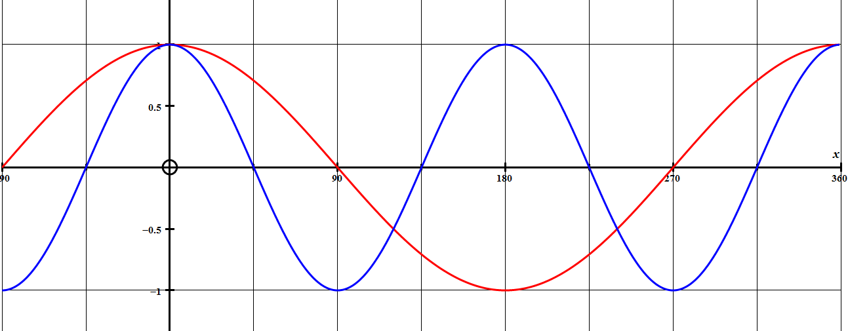

4. Draw the graph of just 1 period of y = sin(20x) on the axes below.

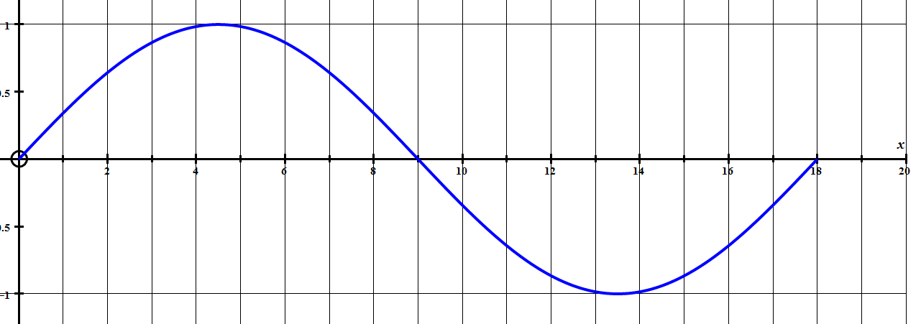

5. Draw the graph of just 1 period of y = sin(30x) on the axes below.

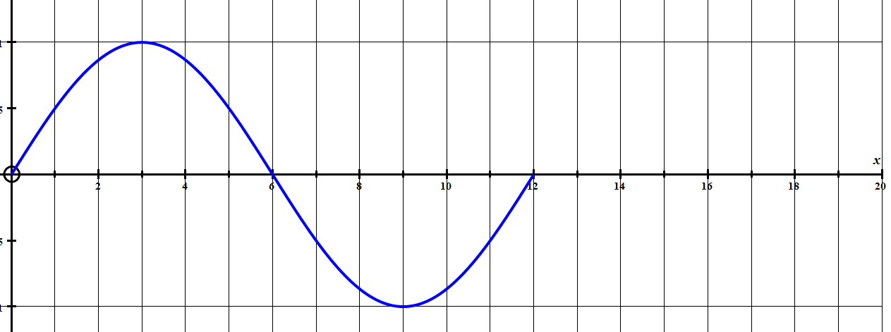

6. Draw the graph of just 1 period of y = cos(30x) on the axes below.

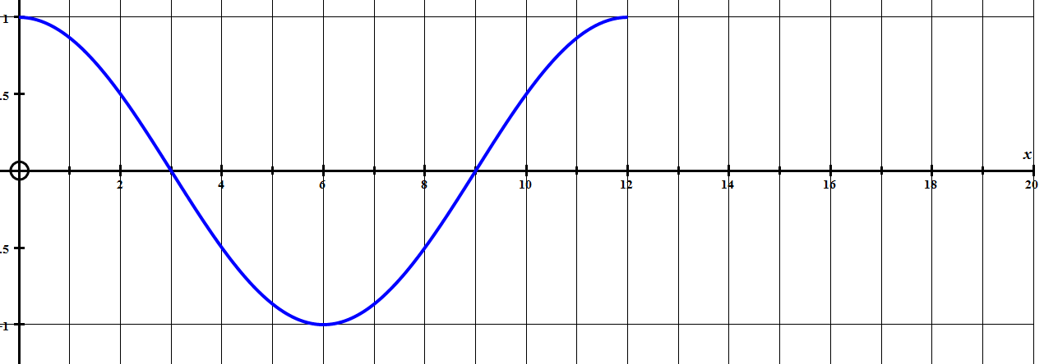

TRIGONOMETRICAL GRAPH PROBLEM 1.

When a fire alarm goes off the sound level instantly starts at 100 decibels and starts to oscillate between 80 to 120 decibels in a sine wave pattern.
The actual equation of the sound level V, at t seconds is:
V = 100 + 20sin(45t)
Draw a clear graph of the volume V, at t seconds on the grid below;
(a) Find the number of seconds taken for the volume to reach its maximum.

(b) Find the number of seconds taken for the volume to reach its minimum.

(c) A volume of 110 decibels and above is considered to damage people’s
hearing. Find the length of time in each cycle that the level is 110 decibels
and over.
If your graph is very accurate, you could read these values from your graph
or you could use your graphics calculator and see when the graphs of
y = 110 and y = 100 + 20sin(45t) intersect.
Make sure your calculator is set in degrees.

(d) It is decided to change the period of the alarm from 8 seconds to 6 seconds
and to start the volume at 80 decibels and only reach a maximum of 110
decibels.
Find the new equation for the volume at t seconds.

TRIGONOMETRICAL GRAPH PROBLEM 1. SOLUTION.

When a fire alarm goes off the sound level instantly starts at 100 decibels and starts to oscillate between 80 to 120 decibels in a sine wave pattern.
The actual equation of the sound level V, at t seconds is:
V = 100 + 20sin(45t)
Draw a clear graph of the volume V, at t seconds on the grid below;

(a) Find the number of seconds taken for the volume to reach its maximum.
t = 2 sec

(b) Find the number of seconds taken for the volume to reach its minimum.
t = 6sec

(c) A volume of 110 decibels and above is considered to damage people’s
hearing. Find the length of time in each cycle that the level is 110 decibels
and over.
If your graph is very accurate, you could read these values from your graph
or you could use your graphics calculator and see when the graphs of
y = 110 and y = 100 + 20sin(45x) intersect.
Make sure your calculator is set in degrees.
Intersect at t = .67 sec and 3.33 sec so length of time is 2.67 sec

(d) It is decided to change the period of the alarm from 8 seconds to 6 seconds
and to start the volume at 80 decibels and only reach a maximum of 110
decibels.
Find the new equation for the volume at t seconds.
sin(45t) has a period of 8 sec because when t = 8 we get sin(360)
so for a period of 6 sec we need sin(60t) to get sin(360)
New equ is V = 80 + 30sin(60t)

TRIGONOMETRICAL GRAPH PROBLEM.2

When a fire alarm goes off the sound level instantly starts at 90 decibels and starts to oscillate between 60 to 120 decibels in a sine wave pattern.
The actual equation of the sound level V, at t seconds is:
V = 90 + 30sin(60t)
Draw a clear graph of the volume V, at t seconds on the grid below;
V decibels
t sec
(a) Find the number of seconds taken for the volume to reach its maximum.

(b) Find the number of seconds taken for the volume to reach its minimum.

(c) A volume of 95 decibels and above is considered to damage people’s
hearing. Find the length of time in each cycle that the level is 95 decibels
and over.
If your graph is very accurate, you could read these values from your graph
or you could use your graphics calculator and see when the graphs of
y = 95 and y = 90 + 30sin(60t) intersect each other.
Make sure your calculator is set in degrees.

(d) It is decided to change the period of the alarm from 6 seconds to 4 seconds
and to start the volume at 80 decibels and only reach a maximum of 100
decibels.
Find the new equation for the volume at t seconds.

TRIGONOMETRICAL GRAPH PROBLEM 2 SOLUTION.

When a fire alarm goes off the sound level instantly starts at 90 decibels and starts to oscillate between 60 to 120 decibels in a sine wave pattern.
The actual equation of the sound level V, at t seconds is:
V = 90 + 30sin(60t)
Draw a clear graph of the volume V, at t seconds on the grid below;

(a) Find the number of seconds taken for the volume to reach its maximum.
t = 1.5 sec

(b) Find the number of seconds taken for the volume to reach its minimum.
t = 4.5sec

(c) A volume of 95 decibels and above is considered to damage people’s
hearing. Find the length of time in each cycle that the level is 95 decibels
and over.
If your graph is very accurate, you could read these values from your graph
or you could use your graphics calculator and see when the graphs of
y = 95 and y = 90 + 30sin(60x) intersect.
Make sure your calculator is set in degrees.
Intersect at t = .16 sec and 2.84 sec so length of time is 2.68 sec

(d) It is decided to change the period of the alarm from 6 seconds to 4 seconds
and to start the volume at 80 decibels and only reach a maximum of 100
decibels.
Find the new equation for the volume at t seconds.
sin(60t) has a period of 6 sec because when t = 6 we get sin(360)
so for a period of 4 sec we need sin(90t) to get sin(360)
New equ is V = 80 + 20sin(90t)
RUNNING MY DINGHY AGROUND!
(a)
My dinghy will run aground (hit the bottom) if the water is under 75 cm deep.
The depth of the water in metres at t hours after high tide is given by the equation D = 2 + 1.5cos(30t)
Draw the graphs of D = 2 + 1.5cos(30t) and D = 0.75 on the grid below.
Find the interval of time during which my dinghy would run aground.
(For best results use your graphics calculator and calculate the intersection points.)
D metres
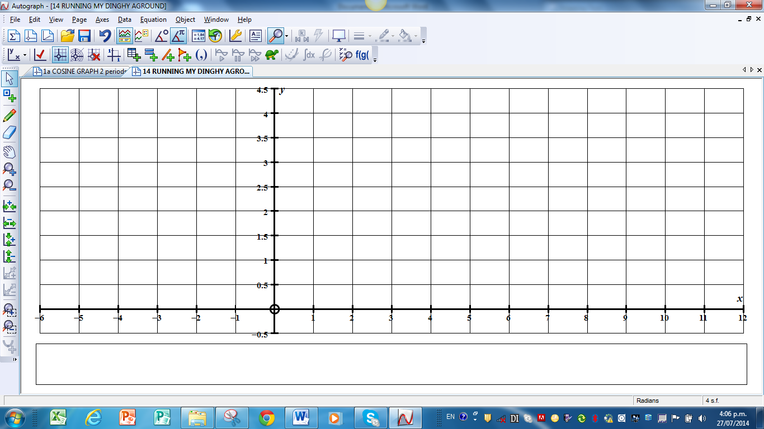
t hours

(b) Explain why y = sin(30t) or y = cos(30t) has a period of 12 hours

(c) In most places the length of time between successive high tides is not
exactly 12 hours.
Explain how you could adjust these equations so that the period becomes:
(i) 12.5 hours

(ii) 12 hours and 40 min (hint 12 + 40 = 12 + 0.667 = 12.667 hours)
60

(iii) 12 hours and 25 mins

SOLUTION
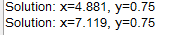
Time is 7.119 – 4.881 = 2.238 hours or 2 hours 14 ½ mins
(b) Explain why y = sin(30t) or y = cos(30t) has a period of 12 hours

For y = sin(x) 1 whole period is from x = 0 to x = 360.

In order for sin(30t) to be 0, t = 0 and for sin(30t) to be 360, t = 12

(c) In most places the length of time between successive high tides is not
exactly 12 hours.
Explain how you could adjust these equations so that the period becomes:
(i) 12.5 hours
For y = sin(x) 1 whole period is from x = 0 to x = 360.
In order for sin(Bt) to be 0, t = 0 and for sin(Bt) to be 360 when t = 12.5
then B×12.5 = 360 so B = 360 = 28.8
12.5
ie sin(28.8t) or cos(28.8t) has a period of 12.5 hours

(ii) 12 hours and 40 min (hint 12 + 40 = 12 + 0.67 = 12.67 hours)
60
In order for sin(Bt) to be 0, t = 0 and for sin(Bt) to be 360 when t = 12.67
then B×12.67 = 360 so B = 360 = 28.41
12.67
ie sin(28.41t) or cos(28.41t) has a period of 12.67 hours

(iii) 12 hours and 25 mins = 12 + 25 = 12 + .417 = 12.417
60
In order for sin(Bt) to be 0, t = 0 and for sin(Bt) to be 360 when t = 12.417
then B×12.417 = 360 so B = 360 = 28.99
12.417
ie sin(28.99t) or cos(28.99t) has a period of 12.417 hours

Understanding Trig Graphs. (Max/Min/Period)

1. y = 60 + 40sin(20x)
Max y value = | Min y value = | Period =

2. y = 11 + 4sin(90x)
Max y value = | Min y value = | Period =

3. y = 18 + 14sin(36x)
Max y value = | Min y value = | Period =

4. y = 10 + 3cos(30x)
Max y value = | Min y value = | Period =

5. y = 60 + 40cos(12x)
Max y value = | Min y value = | Period =

6. Find the equation in the form y = A + Bsin( Cx ) if:
Max y value = 12 | Min y value = 2 | Period = 36

7. Find the equation in the form y = A + Bsin( Cx ) if:
Max y value = 100 | Min y value = 40 | Period = 20

8. Find the equation in the form y = A + Bcos( Cx ) if:
Max y value = 90 | Min y value = 70 | Period = 6

9. Find the equation in the form y = A + Bcos( Cx ) if:
Max y value = 7 | Min y value = 3 | Period = 12.5

10. Find the equation in the form y = A + Bcos( Cx ) if:
Max y value = 12 | Min y value = 2 | Period = 12$\frac{2}{3}$

Understanding Trig Graphs. (Max/Min/Period)
.ANSWERS

1. y = 60 + 40sin(20x)
Max y value = 100 | Min y value = 20 | Period = 360 = 18  20

2. y = 11 + 4sin(90x)
Max y value = 15 | Min y value = 7 | Period = 360 = 4  90

3. y = 18 + 14sin(36x)
Max y value = 32 | Min y value = 4 | Period = 360 = 10  36

4. y = 10 + 3cos(30x)
Max y value = 13 | Min y value = 7 | Period = 360 = 12  30

5. y = 60 + 40cos(12x)
Max y value = 100 | Min y value = 20 | Period = 360 = 30  12

6. Find the equation in the form y = A + Bsin( Cx ) if: y = 7 + 5sin(10x)
Max y value = 12 | Min y value = 2 | Period = 36

7. Find the equation in the form y = A + Bsin( Cx ) if: y = 70 + 30sin(18x)
Max y value = 100 | Min y value = 40 | Period = 20

8. Find the equation in the form y = A + Bcos( Cx ) if: y = 80 + 10cos(60x)
Max y value = 90 | Min y value = 70 | Period = 6

9. Find the equation in the form y = A + Bcos( Cx ) if: y = 5 + 2cos(28.8x)
Max y value = 7 | Min y value = 3 | Period = 12.5

10. Find the equation in the form y = A + Bcos( Cx ) if: y = 7 + 5cos( 28.42x)
Max y value = 12 | Min y value = 2 | Period = 12$\frac{2}{3}$
TRIG PROBLEM ABOUT TIDES

The entrance to a harbour needs to be 10 metres deep for large container ships to enter the harbour.
The depth D, of the water at the harbour entrance can be modelled using the equation D = 12 + 3cos(30t) where D is the depth in metres and t is the number of hours after high tide which is at 12 o’clock midday.

(a) Draw a careful graph of one complete tide cycle from one high tide to the next.
D metres
12
noon
12
Mid –
night
t hours

(b) Use the graph to find the times between which a container ship may not
enter this harbour.

(c) The above model is based on the time between high tides being 12 hours.
If the actual time between high tides is 12 hours 20 minutes find a more
accurate model formula for the above harbour.

TRIG PROBLEM ABOUT TIDES. ANSWERS
The entrance to a harbour needs to be 10 metres deep for large container ships to enter the harbour.
The depth D, of the water at the harbour entrance can be modelled using the equation D = 12 + 3cos(30t) where D is the depth in metres and t is the number of hours after high tide which is at 12 o’clock midday.
(a) Draw a careful graph of one complete tide cycle from one high tide to the
next.
D metres

(b) Use your graph to find the times between which a container ship may not
enter this harbour.
On graphics calculator: in degrees; graph y = 12 + 3cos(30x) and y = 10
G-solve ISCT

Times when depth is under 10 metres are 4.4 to 7.6 hours
(not necessary to say 4:24 pm to 7:36 pm)

(c) The above model is based on the time between high tides being 12 hours.
If the actual time between high tides is 12 hours 20 minutes find a more
accurate model formula for the above harbour.

cos(30x) means that at t = 12 we get cos 360⁰ = 1 (high tide)

so we must find b so that cos (b×12.333) = cos 360
we get b = 360 = 29.19
12.333
More accurate model equation is D = 12 + 3cos(29.19t)

